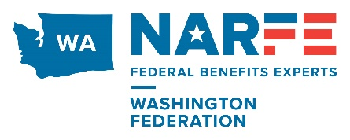
2024 WSF Annual Meeting
October 24, 2024
Agenda
TIME
2:00 – 2:20 | Call to Order; Welcome; Pledge of Allegiance, a BRIEF State of the Federation  -- Cray Henry
2:20 – 2:25 | Region IX Alzheimer’s Report & Presentation of National Award  -- Linda O’Donnell,  -- Lorie Bennett
2:20 – 2:40 | WSF 2025/2026 Election Results, and  Installations (in advance) of New Officers for 2025/2026 Term  - Pat Rudd (or Cray if Pat is not available)  - Steve Roy
2:40 – 3:20  ~3-5 min each | Chapter Presidents’ Reports & Comments  - Scott Robinson, Spokane  - Bob Rust, Seattle & Sequim  - Mike Teefy, Vancouver  - Bill Powers, Bremerton  - Marvin Weiss, Everett  - Tony Merola, Olympia South Puget Sound  - Tina Hedges/Marnie Berry/Autie Bergman, Longview/Kelso  - Nancy Crosby, Tri-Cities  - Elizabeth Parazoo, Colville Valley
3:20 – 3:30 | Break
3:30 - 4:15  ~5-10 each | Federation Advisory Committee Reports & Comments  - Doug Rushton,  - Legislative Report WSF  - PAC Report WSF  - John Thurber, Legislative Coordinator-State  - Charlie Caughlan, Service Officer  - Linda Wallers & Curits Price, WSF Secretary  - Bylaws and reports status  - Webmaster Report  - Mary Traxler & Merry Byrum, Outreach & Strategic Planning Efforts  - Mary Binder  - State of Eastern Washington  - Bea Bull  - State of Western Washington  - Arlene Patton,  - Treasurer’s Report
4:15 – 4:30 | Open Discussion
4:30 | Final Words & Adjournment -Cray Henry

